**DBS LAB 01**

**Lab Task 1**

**MySQL Installation:**

1. **Downloading MySQL**

<https://dev.mysql.com/downloads/installer/> 

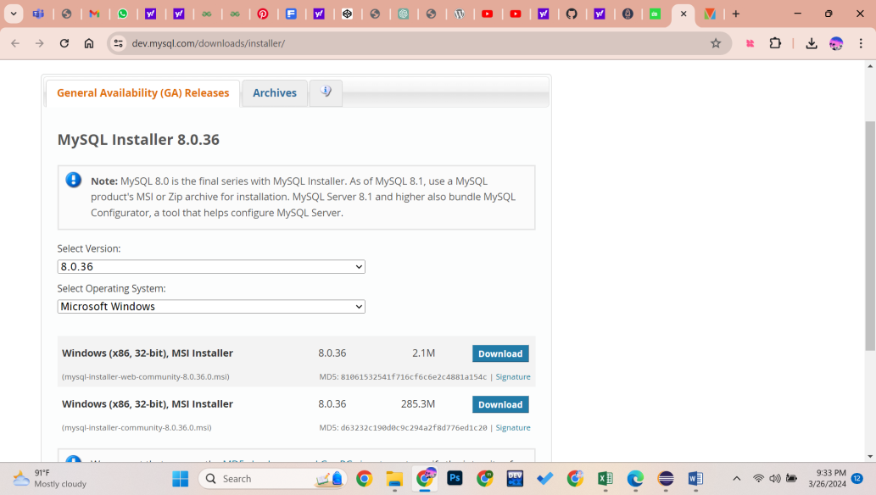

### Launching the Installer and Choosing Your Setup

Once downloaded, locate the file and double-click on it to start the installation process.

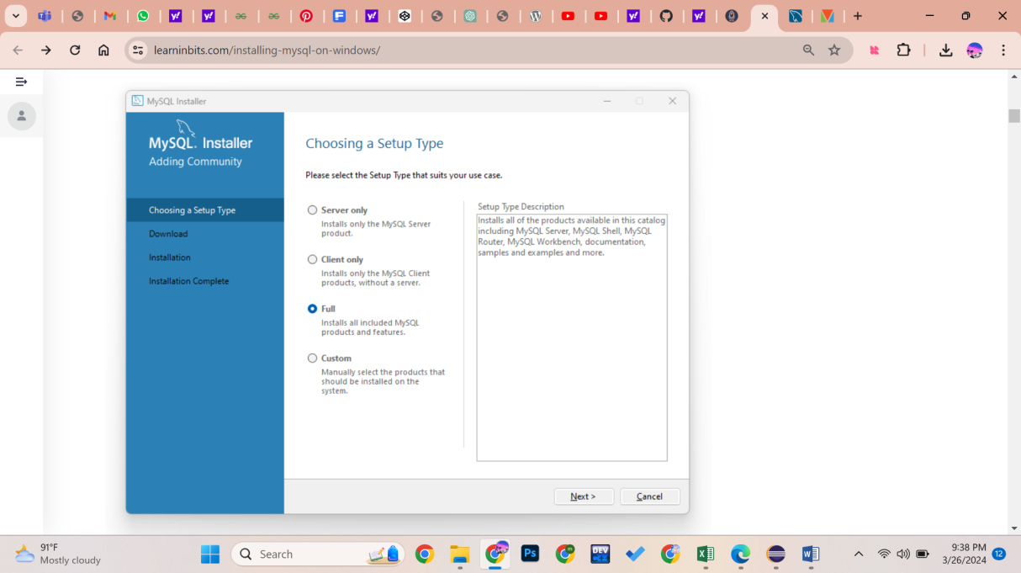

### Product Installation

### 

### Click “Execute” and let the installer do its job. Once done, move ahead by pressing “Next”.

### Configuring MySQL Server

### 

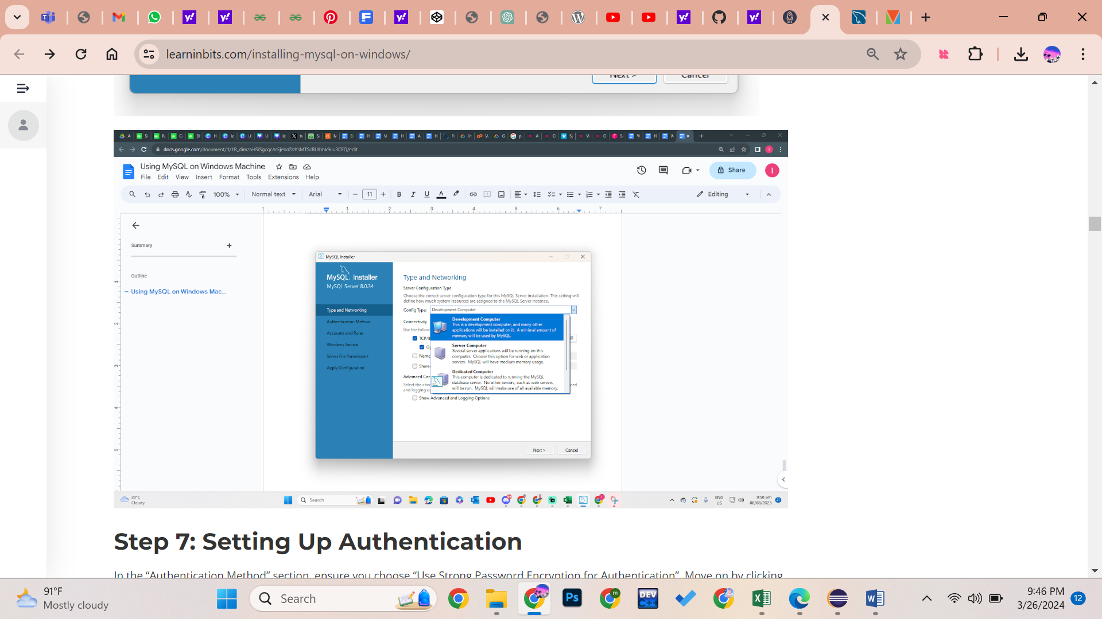

### Setting up Authentication:

### 

### Creating Your Root Account

### 

### Windows Service Configuration

### 

1. **Finalizing Server Configuration**  
     
   On the “Apply Configuration” screen, hit the “Execute” button.  
   Once the server configuration is applied, click “Finish”.

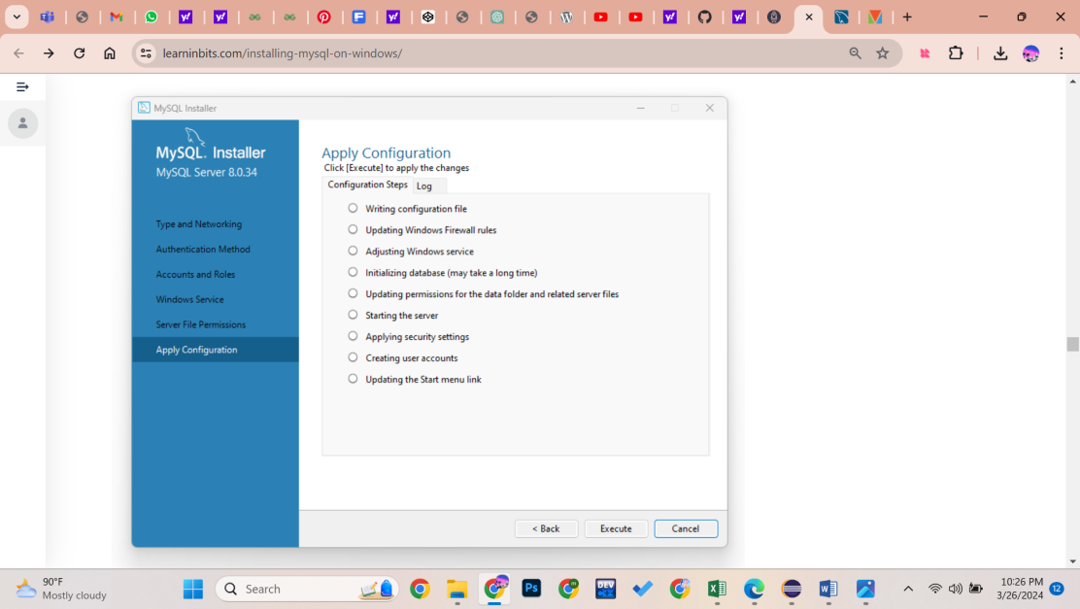

### Connect to Your Server

### 

### Final Configuration Steps

Click “Execute”. After this, click “Finish”.

### 

1. **Installation Complete**

Click “Finish” to close the installer

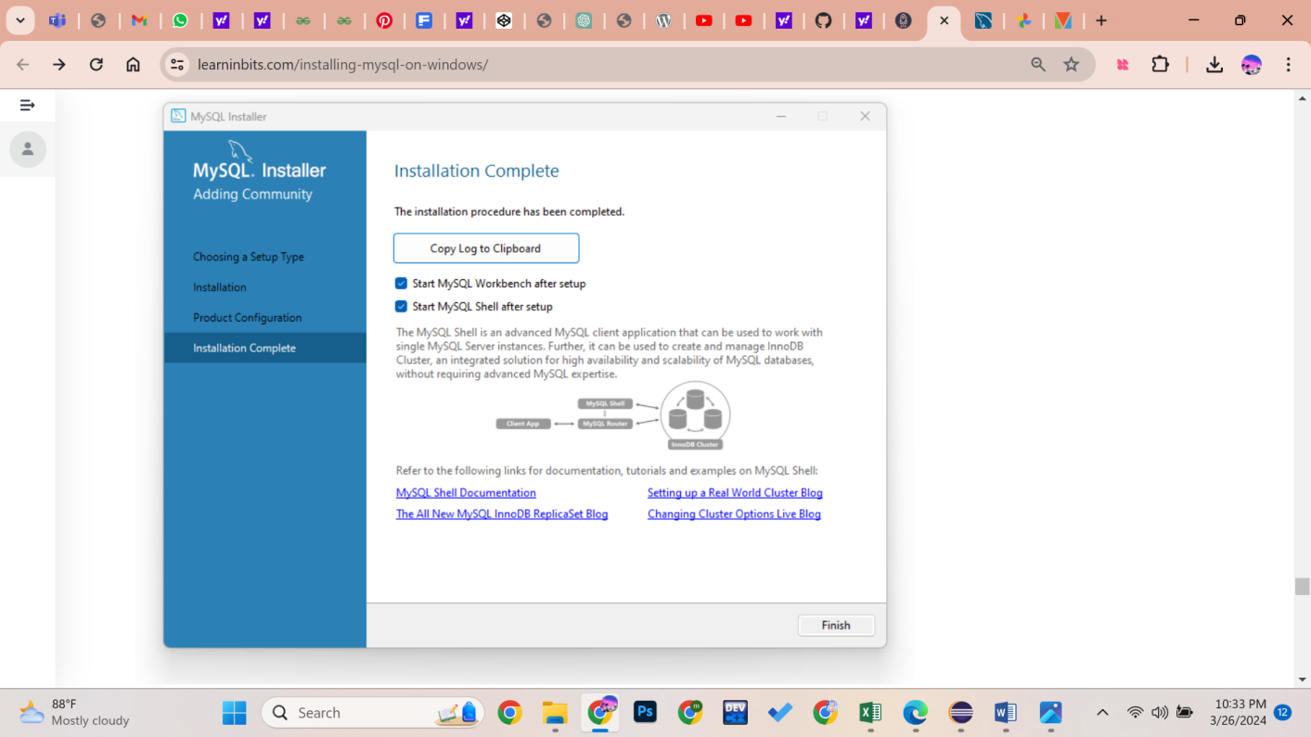

After the installation, the GUI interface of the workbench looks like this.



